Town of Mantua, Utah

PUBLIC WORKS CONSTRUCTION STANDARD DRAWINGS AND SPECIFICATIONS

REVISED AND ADOPTED NOVEMBER 2014

Hansen & Associates, Inc 538 North Main
Brigham City, UT 84302 Ph. 435-723-3491
Fax. 435-723-3492

TOWN OF MANTUA PUBLIC WORKS CONSTRUCTION STANDARD DRAWINGS AND SPECIFICATIONS

This document contains standard drawings depicting the adopted standards for designing and constructing public works facilities in the Town of Mantua, Utah. These standards also apply to the design and construction of privately owned and maintained roads set aside to serve new commercial and residential developments within the community boundaries.

Developments or projects which front along public roads owned and maintained by the State of Utah shall also comply with the applicable standards developed by the Utah Department of Transportation, except that Town of Mantua culinary water and sanitary sewer system facilities shall comply with Town of Mantua Public Works Construction Standards and Specifications.

Town of Mantua Public Works Construction Specifications

Unless otherwise specified herein on the standard drawings and specified by UDOT for roadway improvements along State Highways, construction of public works facilities and infrastructure in Mantua Town shall comply with the latest edition of the American Public Works Association (APWA) Manual of Standard Specifications which have been adopted be reference as a companion document to the standard drawings contained herein. Resolution of any inconsistencies between the included standard drawings and the adopted APWA Manual of Standard Specifications will be made by the Town Engineer. Developers, subdividers, and contractors doing work on public facilities or private development roads in Mantua Town shall be responsible for obtaining a copy of and becoming familiar with the referenced the latest edition of the APWA Manual of Standard Specifications.

Copies of the latest edition of APWA Manual of Standard Specifications can be obtained for $30.00 at the following location:
Utah LTAP Center Utah State University 8205 Old Main Hill
Logan, Utah 84322-8205

Standard Drawing Index Sheet No.
Street Improvement Details - 80' Wide Major Collector Roads 1
Street Improvement Details - 66' Wide Minor Collector and Local Roads 2
Street Improvement Details - 66' Wide Collector and Major Local Roads 3
Street Drainage Details - Typical Dry Well Sump Installation 4
Typical Street Intersection - 66' Wide Minor Collector and Local Roads 5
Typical Cul-De-Sac Detail - For 66' Wide Local Roads 6
Typical Street Sign and Stop Sign & Post Details 7
Sanitary Sewer Details 8
Sanitary Sewer Manhole Details 9
Storm Drain Details 10
Culinary Water System Standard Details 11
Large Diameter Service Meter Details 12
Miscellaneous Culinary Water System Details 13
Standard Mailbox and Newspaper Box Details 14

0
TOWN O F MANTUA
PUBLIC W O R K S C ONSTR UCTION
STANDAR D S

Standard Drawing Index
SIEET 1 - STREET IMPROVEMENT DETAILS - 80' WIDE MAJOR COLLECTOR ROAD
SIEET 2 - STREET IMPROVEMENT DETALS - 66' WIDE MINOR COLLECTOR AND LOCAL ROADS SIEET 3 - STREET IMPROVEMENT DETALS - 66' COLLECTOR AND MAJOR LOCAL ROADS SIEET 4 - STREET DRAINAGE DETALS - TYPICAL DRY WELL SUMP INSTALLATION
SIEET 5 - TYPICAL STREET INTERSECTION - 66' WIDE MINOR COLLECTOR AND LOCAL ROADS SIEET 6 - TYPICAL CUL;-OE-SAC DETAL - FOR 66' WIDE LOCAL ROADS
SIEET 7 - TYPICAL STREET SIGN AND STOP SIGN & POST DETALS SIEET 8 - SANITARY SEWER DETALS
SIEET 9 - SANITARY SEWER MANHOLE DETALS
RECOMMENDED: SIEET 10 - STORM DRAIN DETALS
SIEET tt - CULINARY WATER SYSTEM STANDARD DETALS SIEET 12 - LARGE DIAMETER SERVICE METER DETALS
Jim Flint, P.E. Date SIEET 13 - MISCELLANEOUS CULINARY WATER SYSTEM DETALS SIEET 14 - STANDARD MALBOX AND NEWSPAPER BOX DETALS

TOWN OF MANTUA PLANNING Date COMMISSION CHAIRMAN
APPROVAL: | PUBLIC WORKS CONSTRUCTION SPECIF/CATIONS: | HANSE N & ASSO CIATES, INC.  Consulting Engineers and Land Surveyors  538 Nort h Main Street, Brigham, Utah 84302  Visit us at w w w. haies. net  Brigham City Ogden Logan  (435) 723-3491 (801) 399-4905 (435) 752-8272
 | WHERE APPLICABLE, AND UNLESS OTHERWISE SPECIFIED, CONSTRUCTION
 | OF PUBLIC WORKS FACILITIES AND INFRASTRUCTURE SHALL COMPLY WITH
 | THE 20 12 EDITION OF THE AMERICAN PUBLIC WORKS ASSOCIATION
 | MANUAL OF STANDARD SPECIFICATIONS PUBLISHED BY THE UTAH CHAPTER
MANTUA TOWN MAYOR Date | OF THE AMERICAN PUBLIC WORKS ASSOCIATION WHICH ARE ADOPTED BY
 | REFERENCE AS A COMPANION DOCUMENT TO THESE DRAWINGS.
 | RESOLUTION OF ANY INCONSISTENCIES BETWEEN THESE DRAWINGS AND
 | THE ADOPTED SPECIF/CATIONS WILL BE MADE BY THE TOWN ENGINEER.
MANTUA TOWN CLERK Date

O_

0
f----

C)

:s
0

N
n
CXJ 0
N
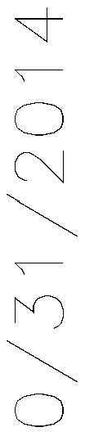
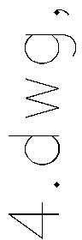

n
I

0

0
N

Ul
0
De
<(
0
z
<(
f---­
Ul
z

:s
0
f----

<(
=i
f---­
z

<(
2
/ en u
L
0
u
C
0
+-'
Ul

C
s
0
f----

0
::J
+-' C 0
2
/ en u
L
0
u
C
0
+-'
Ul

u
/
z

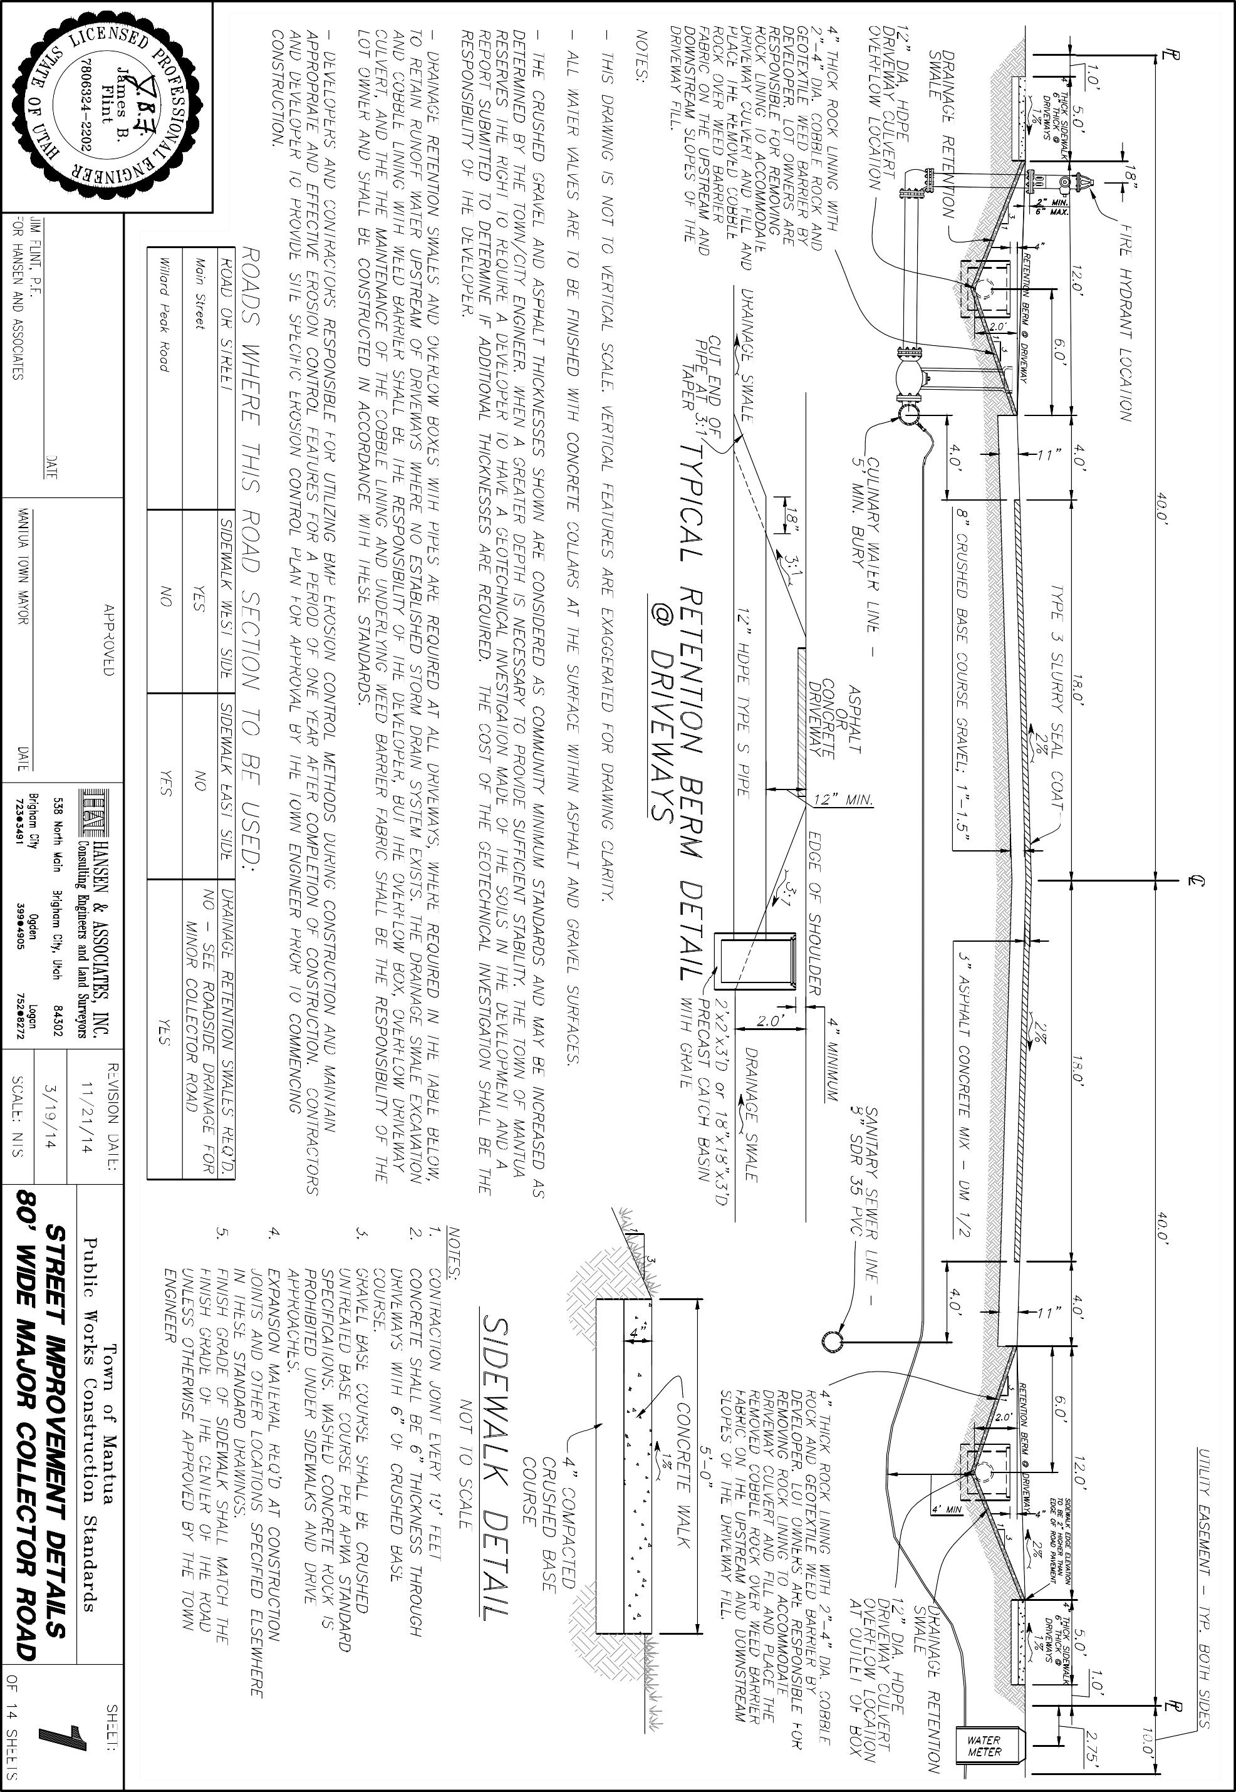

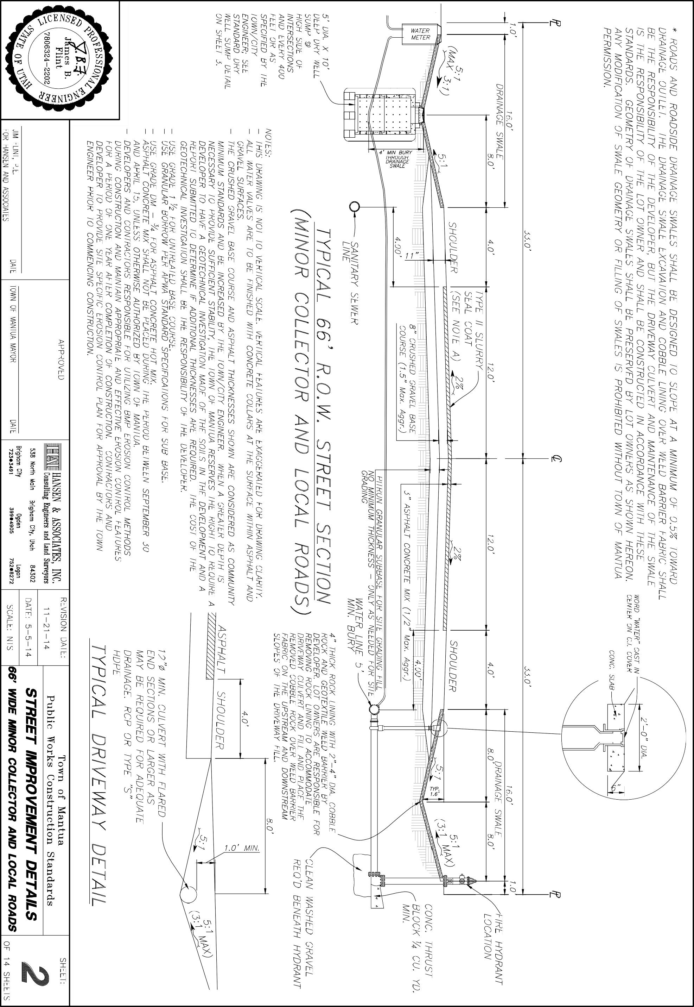

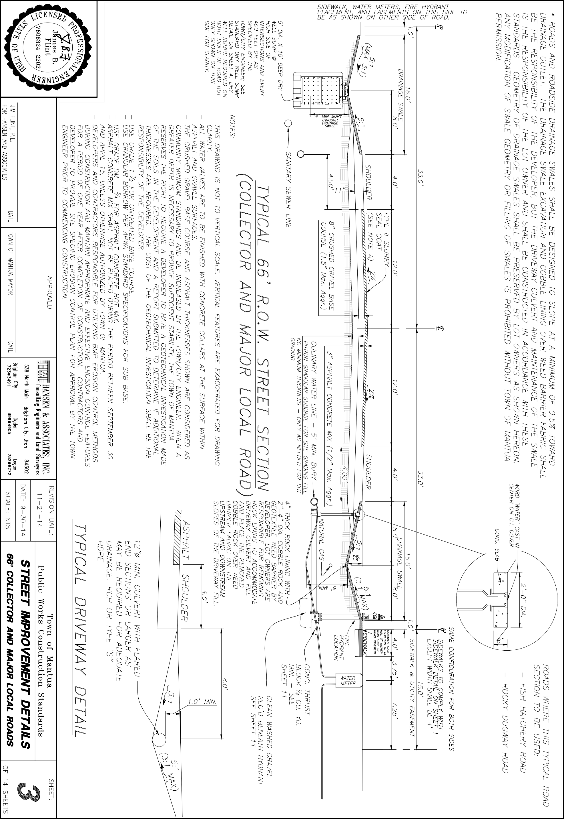

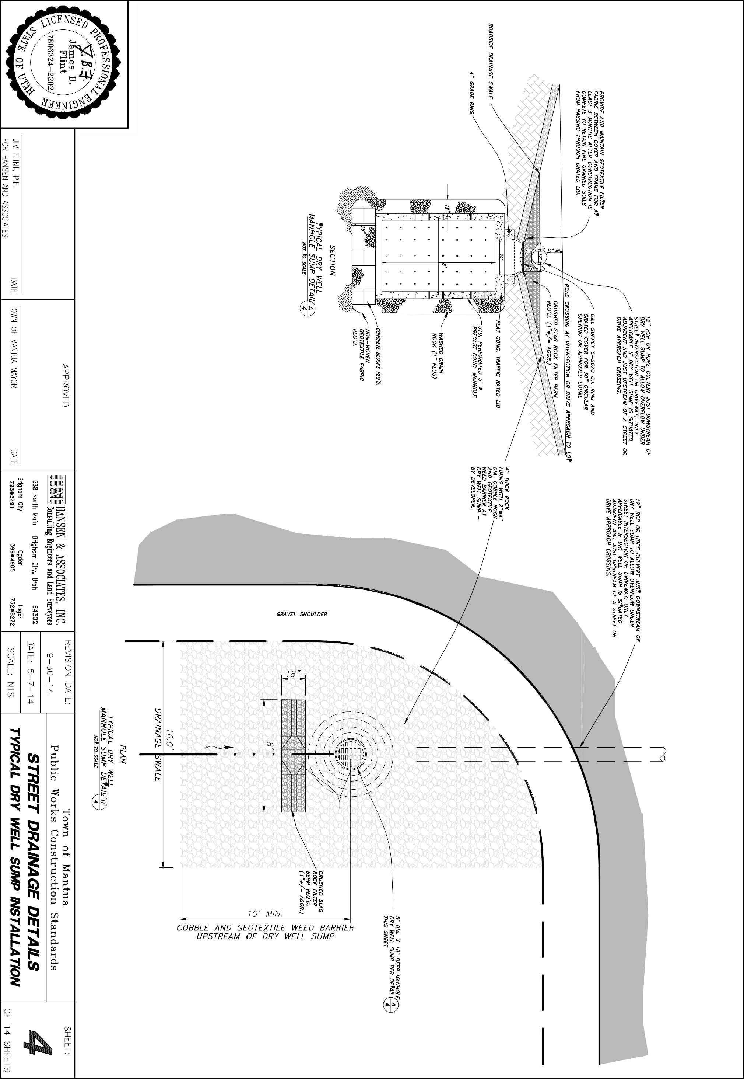

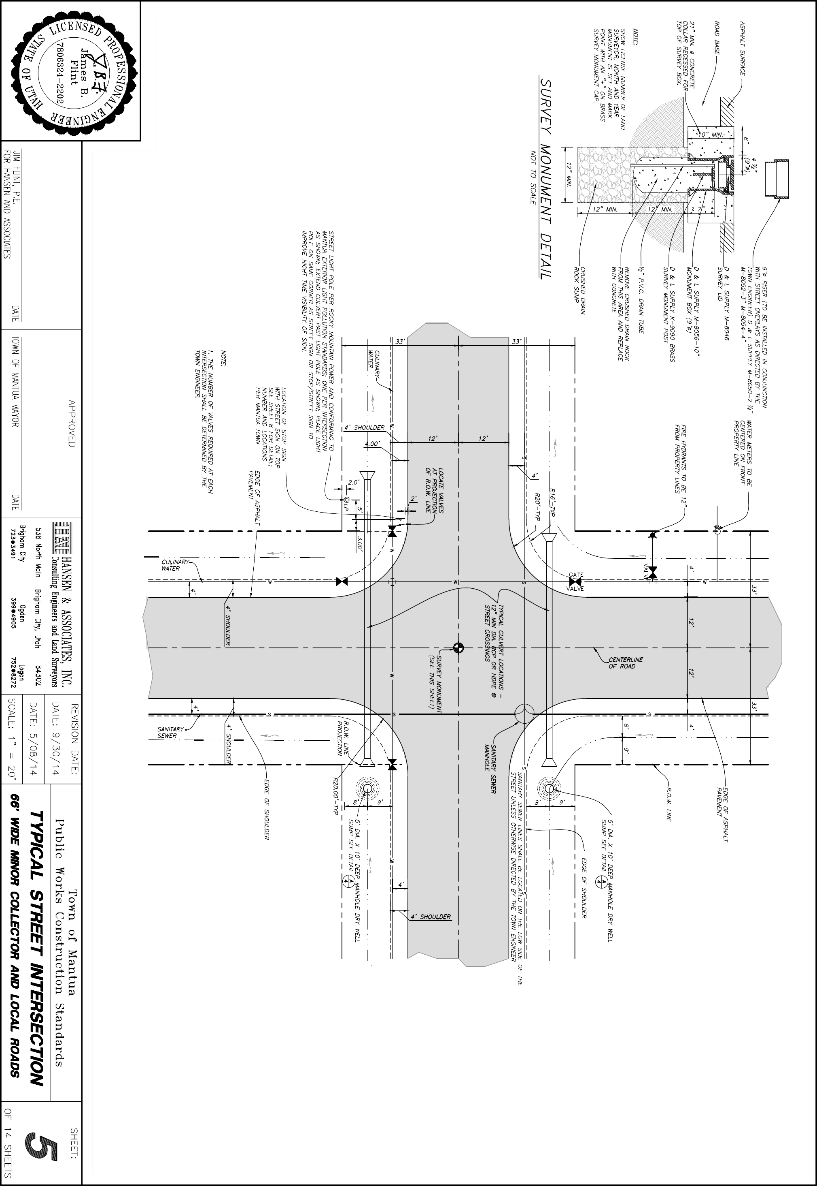

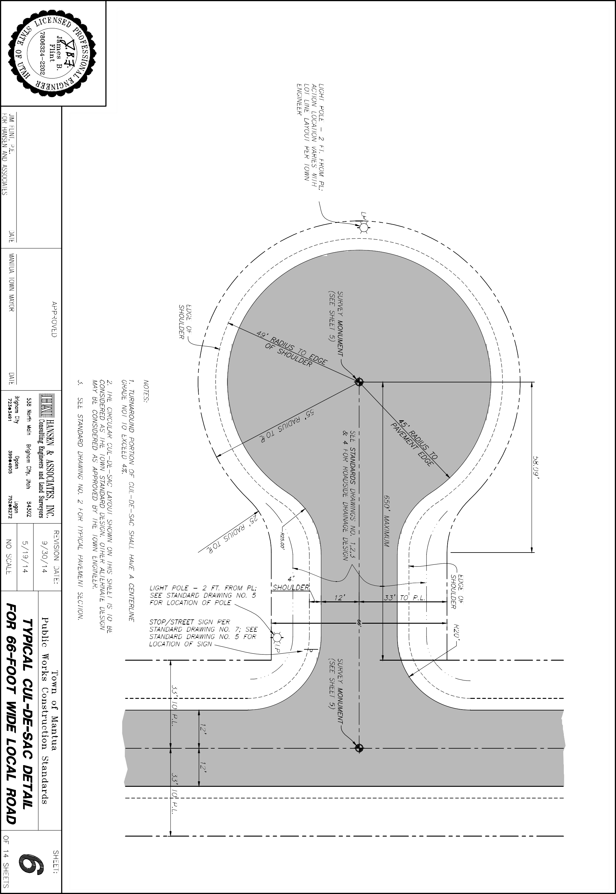

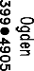
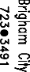

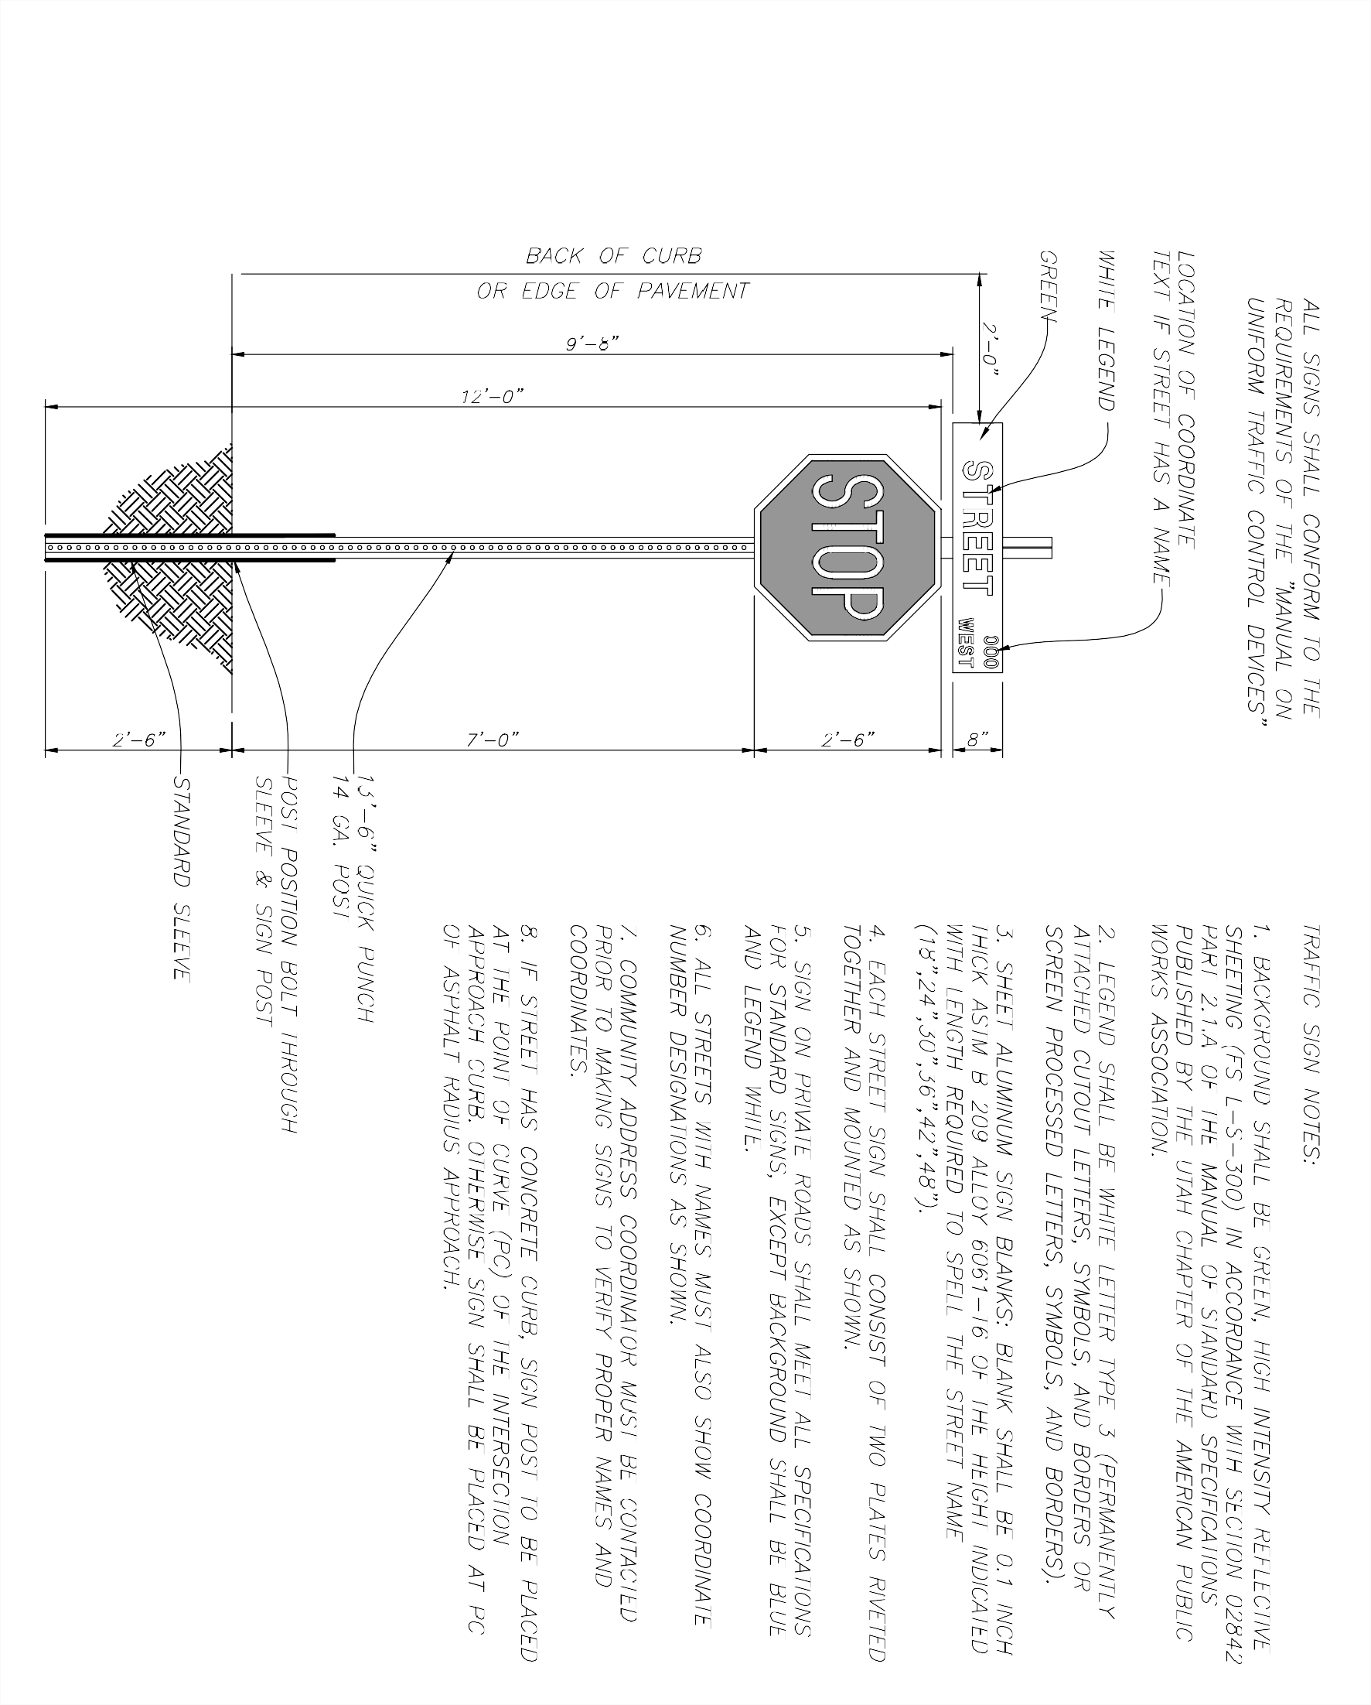

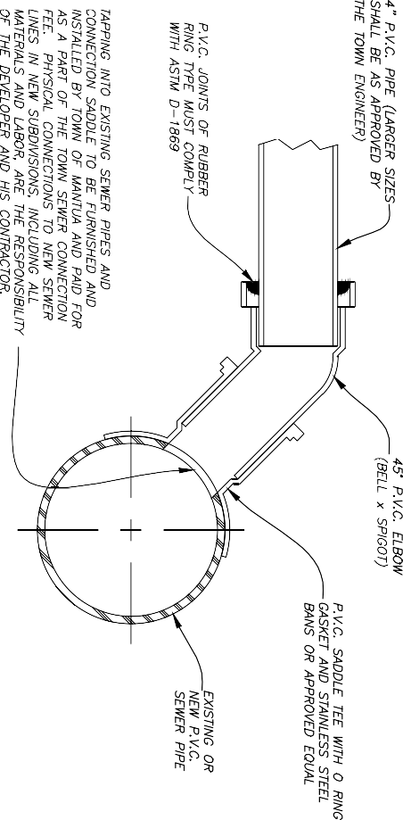
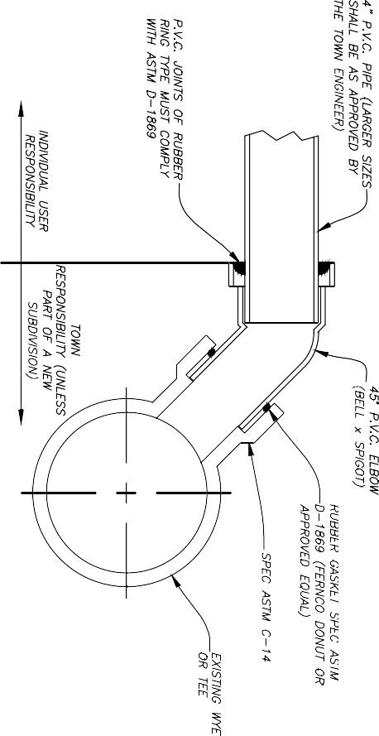
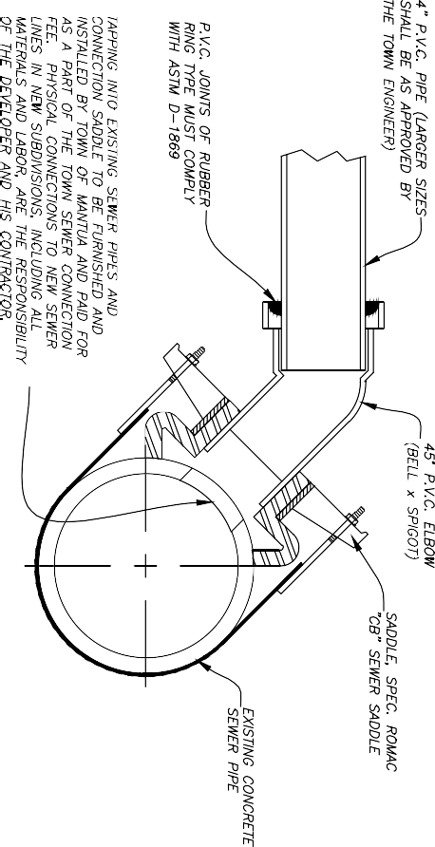
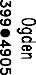
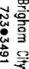
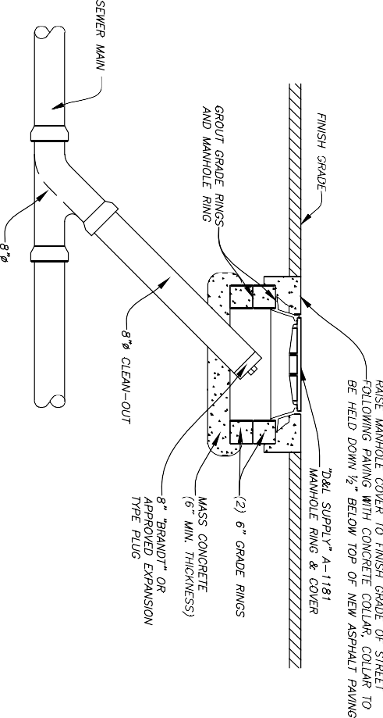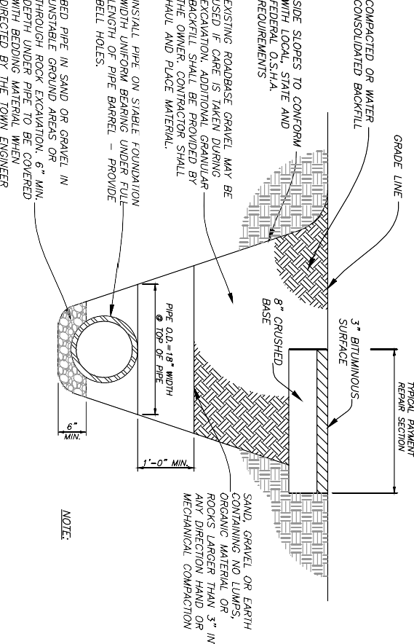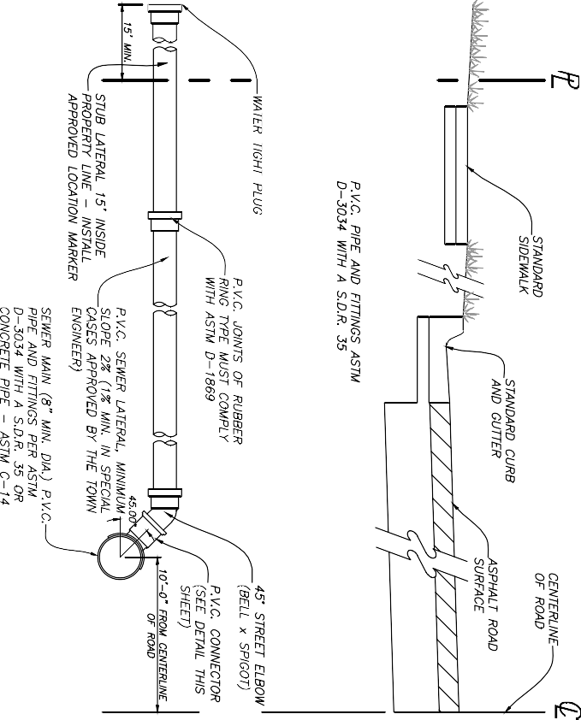

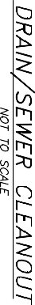

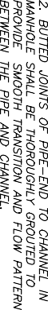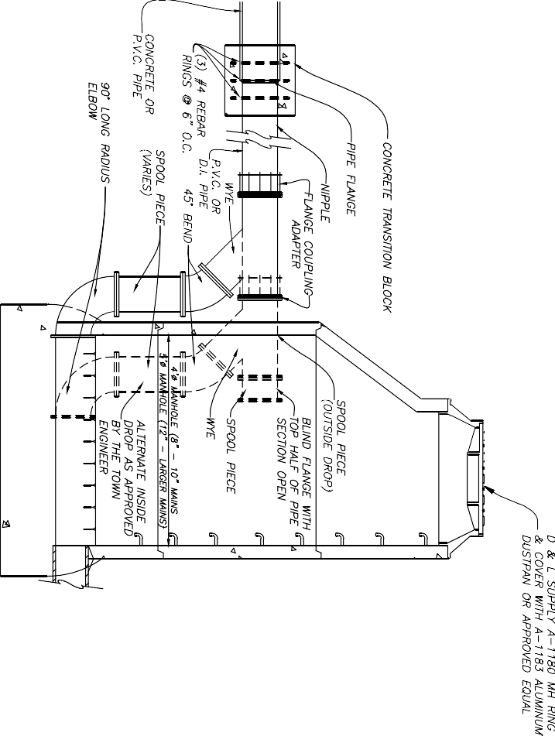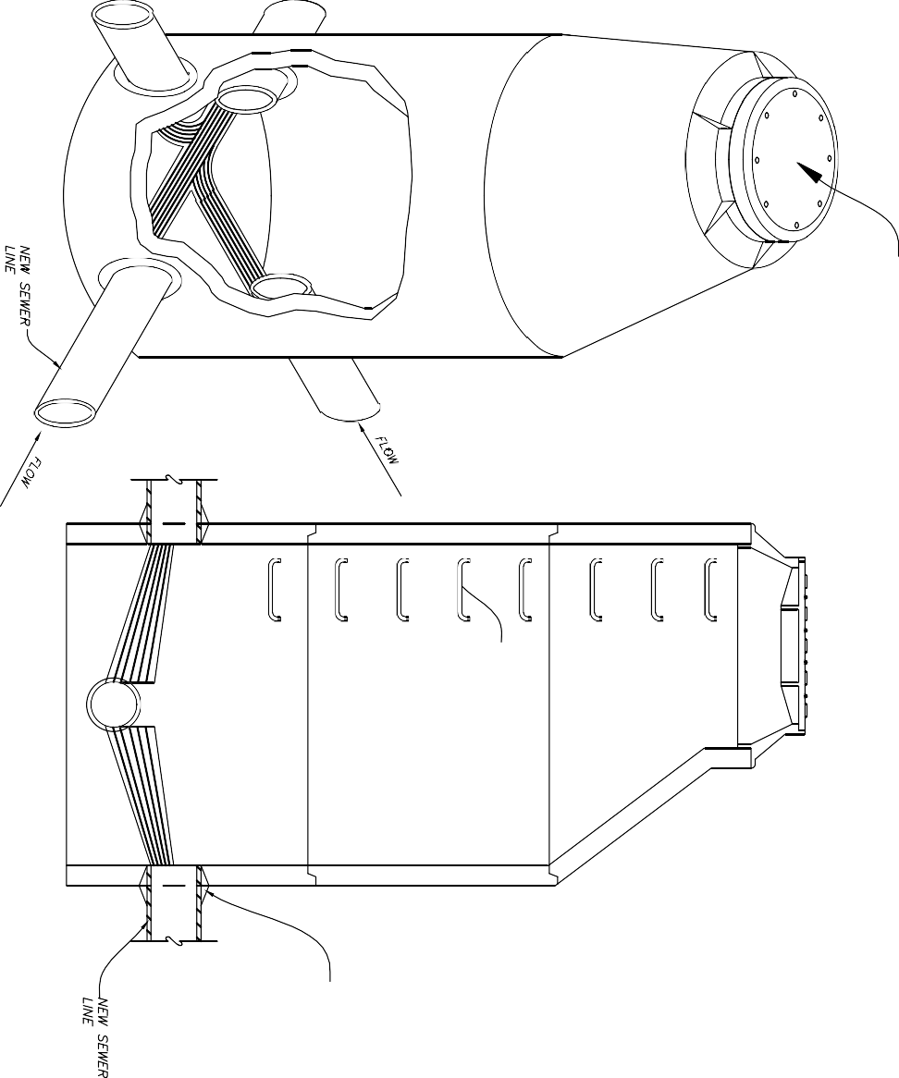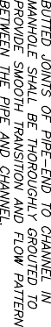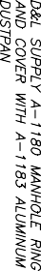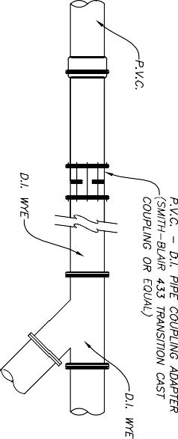

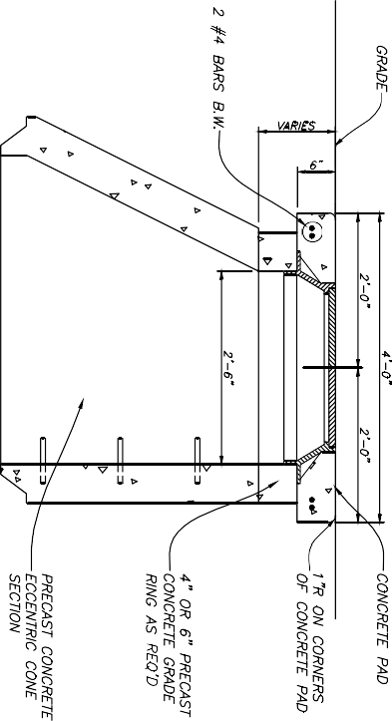

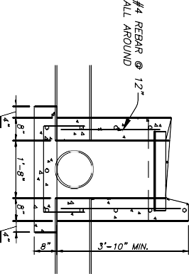
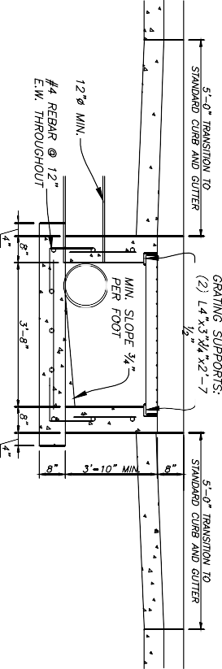
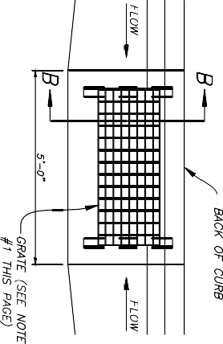
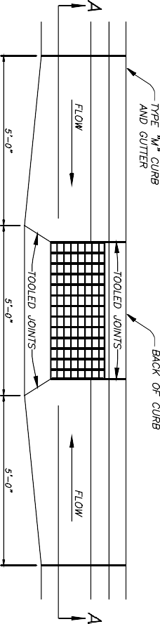
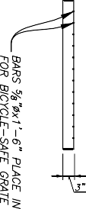
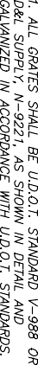
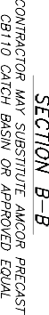
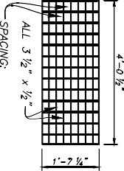

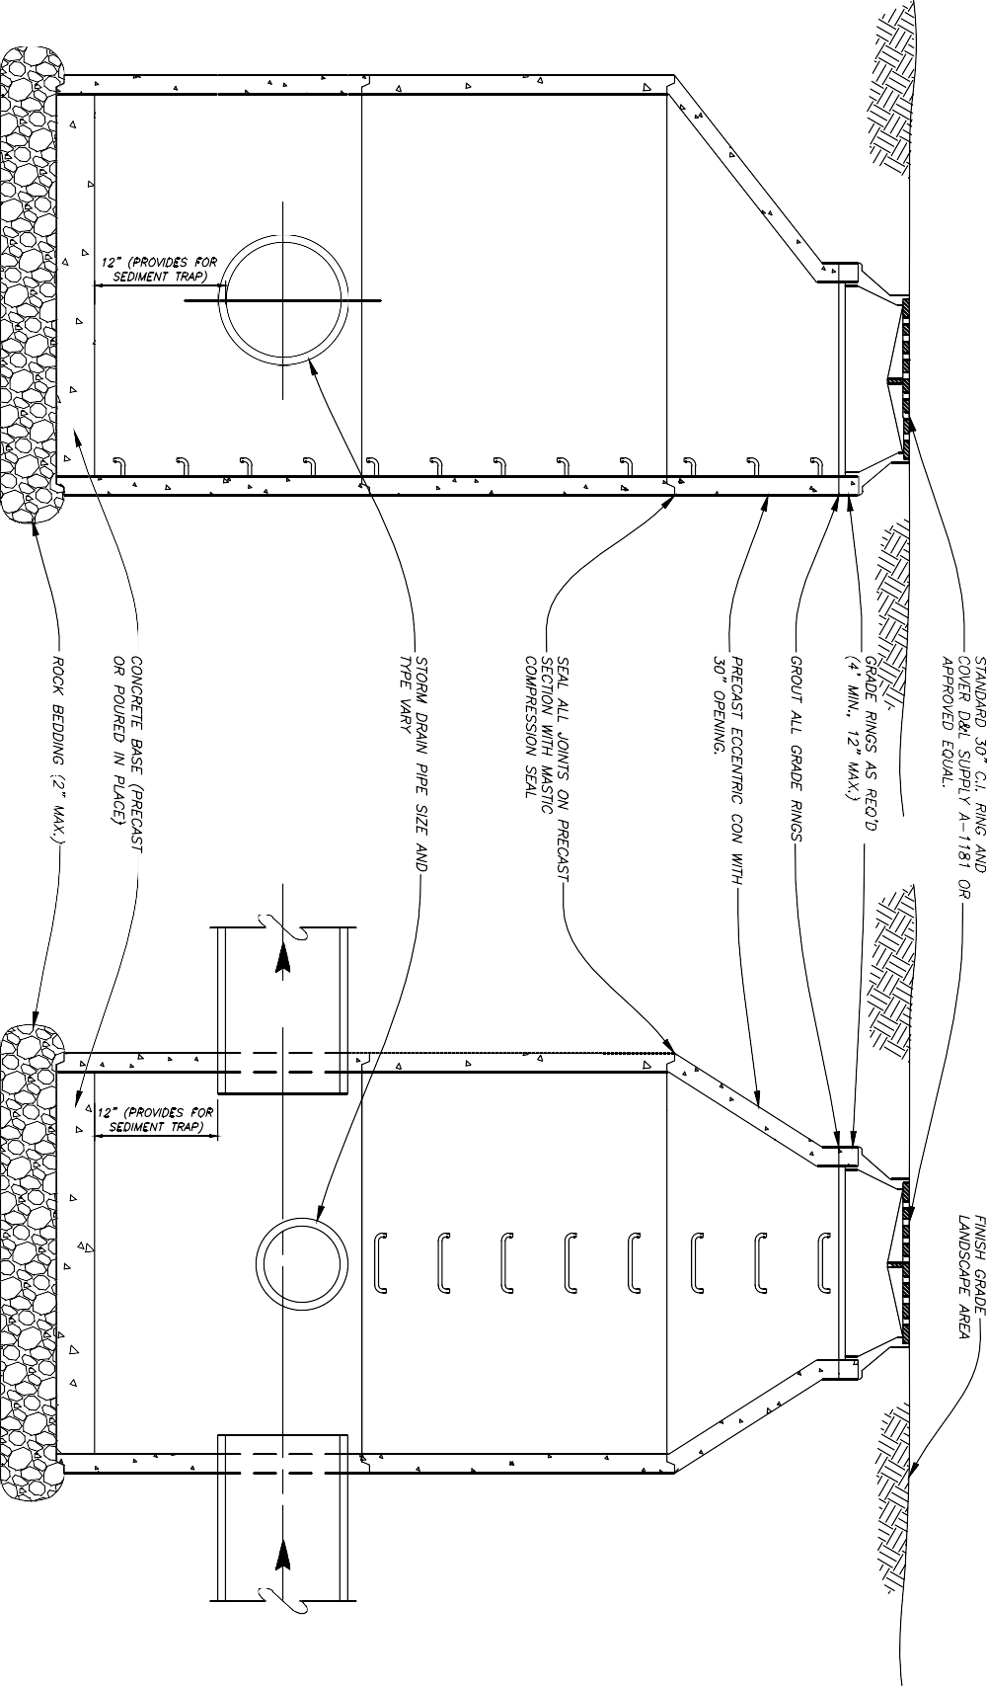

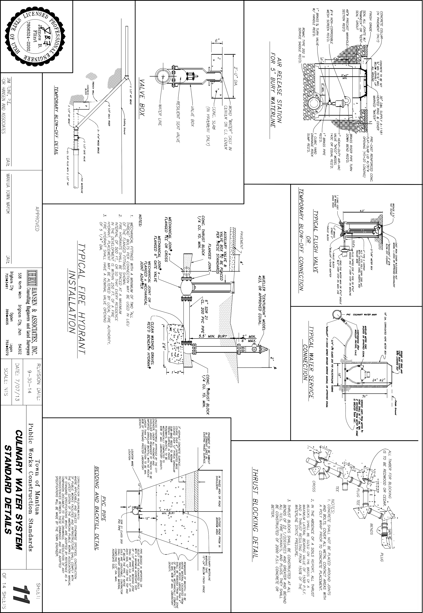

- . M£I£R PLAC£M£NT:  - IN NEW CONSTRUCnON, INSTALL M£I£R AT C£NT£R OF LOT OR P£R AGENCY R£QUIR£M£NTS.  8. ALL M£r£RS AR£ TO 8£ INSTALLED IN TH£ PARK STRIP OR AS SHOWN  £LSEWH£R£ IN THESE STANDARD DRAWINGS.  C. DO NOT INSTALL M£r£RS UNDER DRN£WAY APPROACHES, SIDEWALKS, DR CURB &- GUTTER.  - PIP£: INSTALL TYP£ 'K' COPPER PIP£ FOR 1.5" AND 2" M£I£R INSTALLAnONS FROM MAIN UN£ PIP£ TO PROPERTY UN£ COORDINATE WITH unuTY AGENCY FOR TYP£ OF PIP£ TO 8£ USED OUTS/0£ OF RIGHT-OF-WAY.  - AL TERNATE: TURBIN£ M£I£RS AR£ R£QU/R£D ON ALL SYSTEMS USED  £XCLUSN£LY FOR IRRIGAnON OR FIR£ PROTECnON. WHERE DOMESnc US£ IS APPUCABL£ US£ A STANDARD M£r£R.  - BYPASS VALV£: LOCK IN OFF POSmON.  - BLOCKING: US£ CLAY BRICK OR CONCR£I£ BLOCK.  - CONCR£I£ BOX:  - CENTER FRAM£ AND COVER OVER WAT£R M£I£R.  8. ALLOW 1 INCH CL£ARANC£ AROUND WATERUN£ WH£R£ LIN£ PASSES THROUGH WALL. SEAL OPENING WITH COMPRESS/BL£ SEAL  7. INSP£CnON: PRIOR TO BACKFILUNG AROUND TH£ M£r£R BOX, S£CUR£ INSP£CnON OF INSTALLAnON BY TOWN £NGIN££R.  GRADE RING  I Ya• CUSTOM SETT£R 5'x5'x4'd  WITH BYPASS PRECAST BOX &- LID  2" CUSTOM SETT£R W/0 BOTTOM  WITH BYPASS  TEMPORARILY SET  / PRECAST BOX AND  POUR CONCRETE FOOnNG IN PLACE  4 • DRAIN GRAVEL  BYPASS VALVE SEE NOTE 4  SECTION  2 " TURBO METER  BRASS PIPE  SEE NOTE 5  !!::  0  Ii I  SECTION A-A l ALTERNATE  TURBO METER INSTALLATION SEE NOTE 3  1/2" AND 2" METER |  |  |  | -Y,"I (4}REO'D  .. PIPE  • •  HOT DIP GALVANIZE ..  - T£R FABRICATION  ROMAC MJRG MECHANICAL JOINT RETAINER GLAND  .. WALL PENETRATION DETAIL  LADDER DETAIL  NOT£ 1: OR OTHER METER BRAND P£R COMMUNITY  WATER DEPARTMENT  CONCRETE VAULT .  6x6x6.5 AMCOR PRECAST 6x6x6.5 AMCOR PRECAST  <o CONCRETE VAULT  I/ WALL PENETRAnON PIPE RESTRAINT  --111-----'IP"'-='ll'-=>'11-4.-- -------./--•'11"·'-"'l -111--- 9  6.0' 6.0'  PLAN PLAN  TOP REINFORCED FO TOP REINFORCED FO  HS-20 TRAFFIC HS-20 TRAmc  LOADING LOADING  - ANCHOR BOLTS *" ANCHOR BOLTS  TYP. TYP.  GROUT LINES IN GROUT LINES IN  PRECAST OPENINGS PRECAST OPENINGS  ALL FlmNGS SHALL BE ALL FlmNGS SHALL BE  AWWA C-110 WITH 125 AWWA C-110 WITH 125  LB. FLANGES ALL PIPING LB. FLANGES ALL PIPING  SHALL BE DUCnLE IRON SHALL BE DUCnLE IRON  PIPE CLASS 350 PSI MIN. PIPE CLA.SS 350 PSI MIN.  SECTION SECTION  3" WATER METER STATION 4" & 6" WATER METER STATION  CONSTRUCnON R£0UIR£M£NTS:  WHERE APPUCABL£ AND UNLESS OTH£RWIS£ SP£CIFl£0, CONSTRUCnON OF PUBUC WORKS FACIL/nES AND INFRASTRUCTURE SHALL COMPLY WITH  THE LATEST £DmON OF THE AMERICAN PUBUC WORKS ASSOCIAnON MANUAL OF STANDARD SP£CIFICAnONS WHICH ARE ADOPTED BY REFERENCE AS A COMPANION DOCUMENT TO THESE DRAWINGS. RESOLUnON OF ANY INCONSISTENCIES BETWEEN THESE DRAWINGS AND TH£ ADOPTED SP£CIFICAnONS WILL 8£ MAD£ BY TH£ TOWN £NG/NEER.
 |  |  | APPROVED  MANTUA TOWN MAYOR |  | DATE | HANSEN & ASSOCIATES, INC.  Consulting Engineers and Land Surveyors  538 North Moin Street, Brighom, Utoh 84302  Visit us at www.haies. net  Brigham City Ogden Logan  (435} 723-3491 (801} 399-4905 (435) 752-8272 | REVISION DATE: | Town of Mantua | SHEET:
 | JIM FLINT, P.E.  FOR HANSEN AND ASSOCIATES | DATE |  |  |  |  | 9-30-14  t------------  DATE: 1/23/09  t------------  SCALE: NONE | Public Works Construction Standards | 12  OF 14 SHEETS
i
LARGE DIAMETER SERVICE
i
METER DETAILS

Q_
PIP£ & FTTTlNG SCH£DUL£
NO. | 0£SCRIPTION | TYP£ | J" UN£ | 4• UN£ | 6" UN£
7 | 5£NSUS W-JSODR M£T£R W/STl?AIN£R (S££ NOT£ 1) | Fl. | J" | - | -
2 | 5£NSUS W-100DR M£T£R W/STRA1N£R (5££ NOT£ 1) | Fl. | - | 4 | -
J | 5£NSUS W-200DR M£T£R W/ STRA1N£R (S££ NOT£ 1) | Fl. | - | - | 6"
 | R£S/U£NT SE"AT G<T£ VAL W/IWIDWHffi. | Fl.xFI. | J" | - | -
5 | R£S/U£NT SE"AT G<T£ VAL W/IWIDWHffi. | Fl.xFI. |  |  | 6"
6 | ROMAC FCASO 1 Fl.ANG£D COUPUNG ADAPTcR | Fl.xP£ | J | 4 | 6 "
7 | ROMAC DJ400 DISMANTLING JOINT | Fl.xFI. | J" | 4• | 6"
8 | T££ | Fl. | J" |  | 6"
9 | 90" £LBOW | Fl. | y | 4 | 6"
10 | SPOOL Pl£C£ | Fl.xP£ | 3•x30" | 4•x30• | 6•x30•
71 | SPOOL Pl£C£ | Fl.xFI. | J x,JI | 4 x29 | 6·x26•
12 | SPOOL P/£C£ | Fl.xP£ | 3•x12• | 4"xt2 " | 6"x12"
7J | SPOOL Pl£C£ | Fl.xP£ | :rxS6" | 4 xS6 | 6 "x54 1/2"
14 | SPOOL Pl£C£ | Fl.xP£ | 3·xs6 | 4·x.s6 · | 6 "x54 1/2"
15 | ROMAC 501 F1.£XIBL£ PIP£ COUPUNG | Fl.xP£ | 3'"x23" | 4"x26 1/2" | 6"x22 J/4 "
16 | ROMAC WRG M£CIWI/CAL JOINT R£TAIN£R GWID |  | J" |  | 6"
17 | ,J "x4 " REDUCER | Fl.xFI. | J | 4 | -

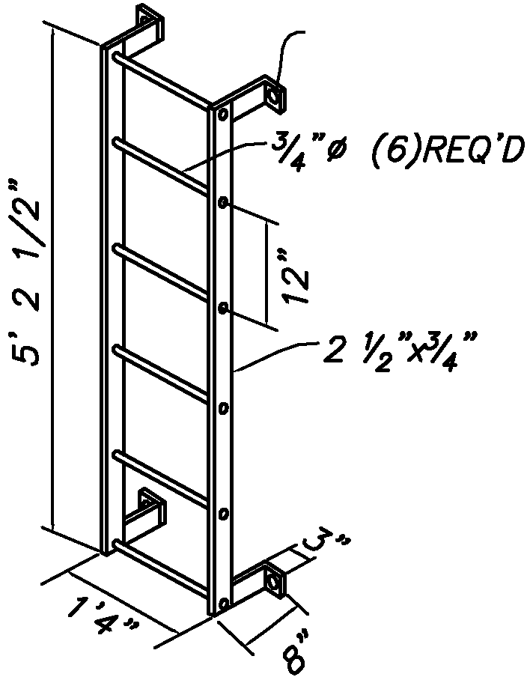
Li_
0
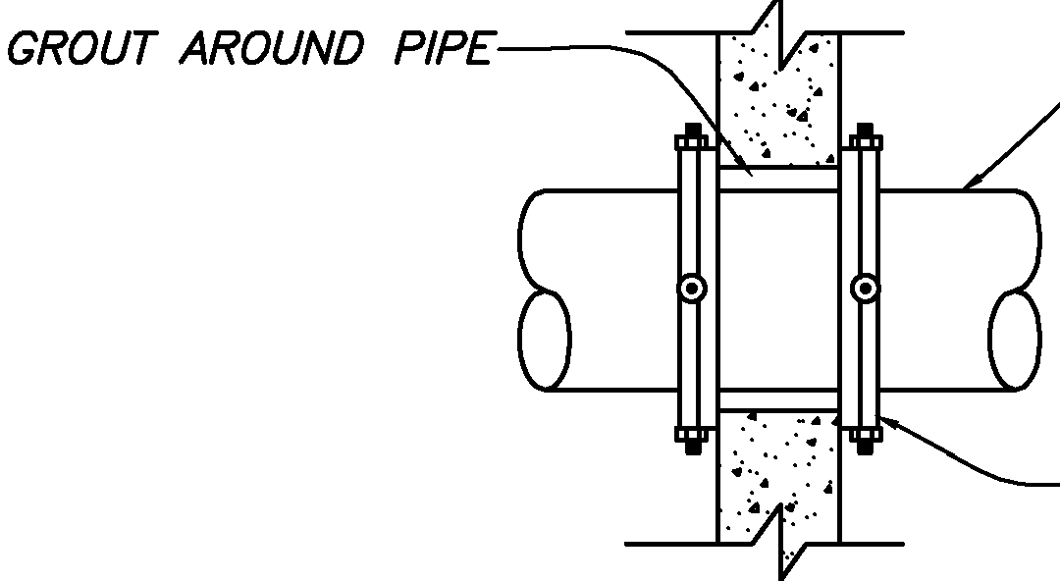
O_

0
f-

(_')

s
0

2
<(

I";
N
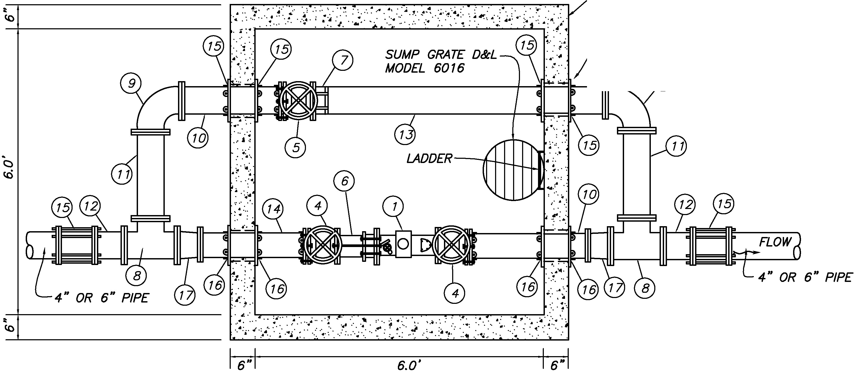
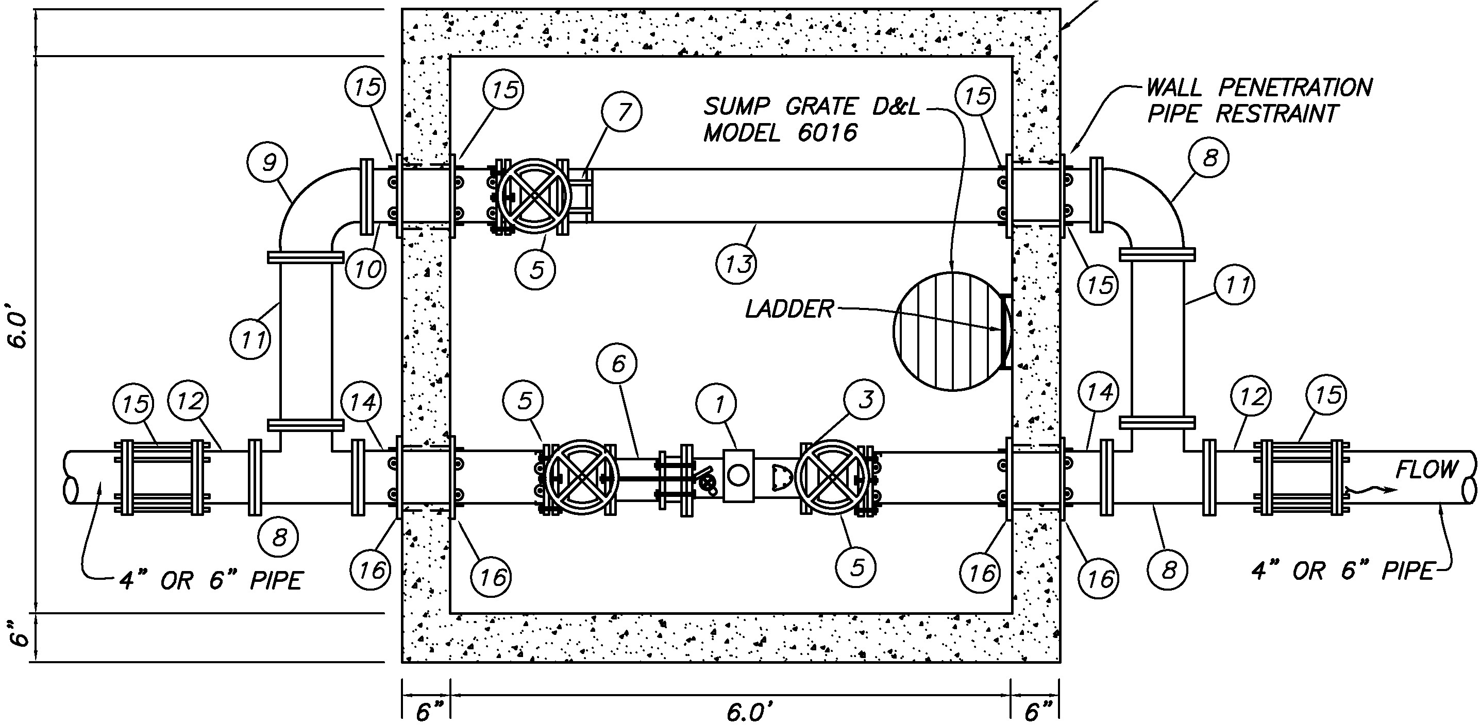
N

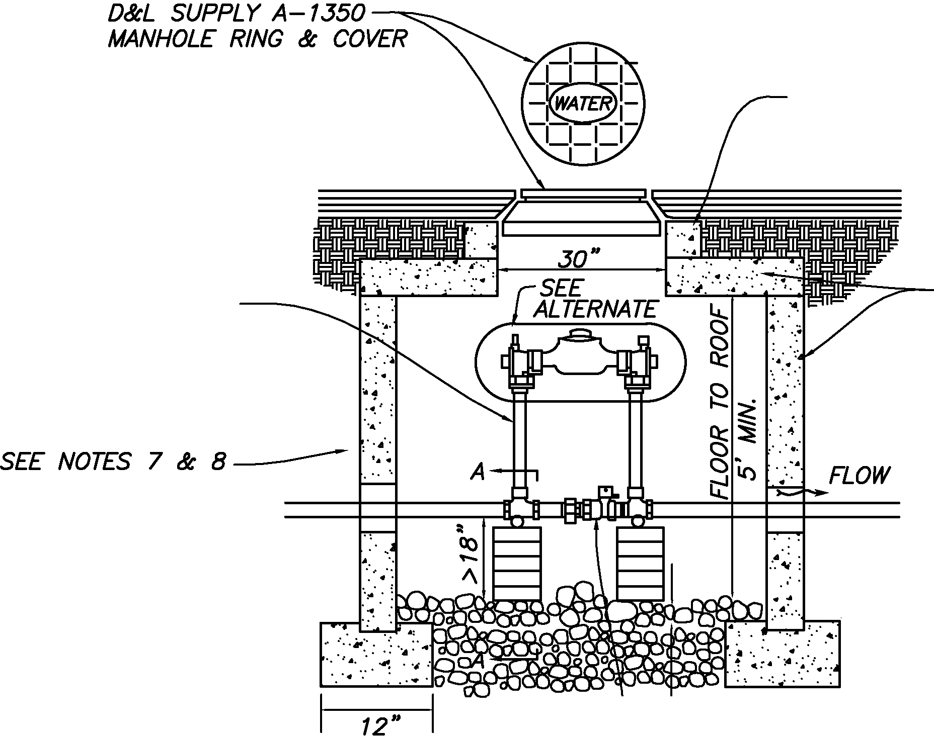
I";
I
0

0
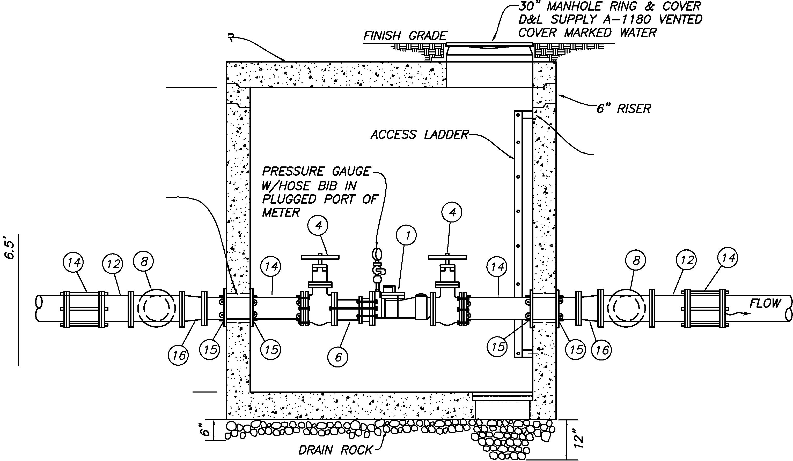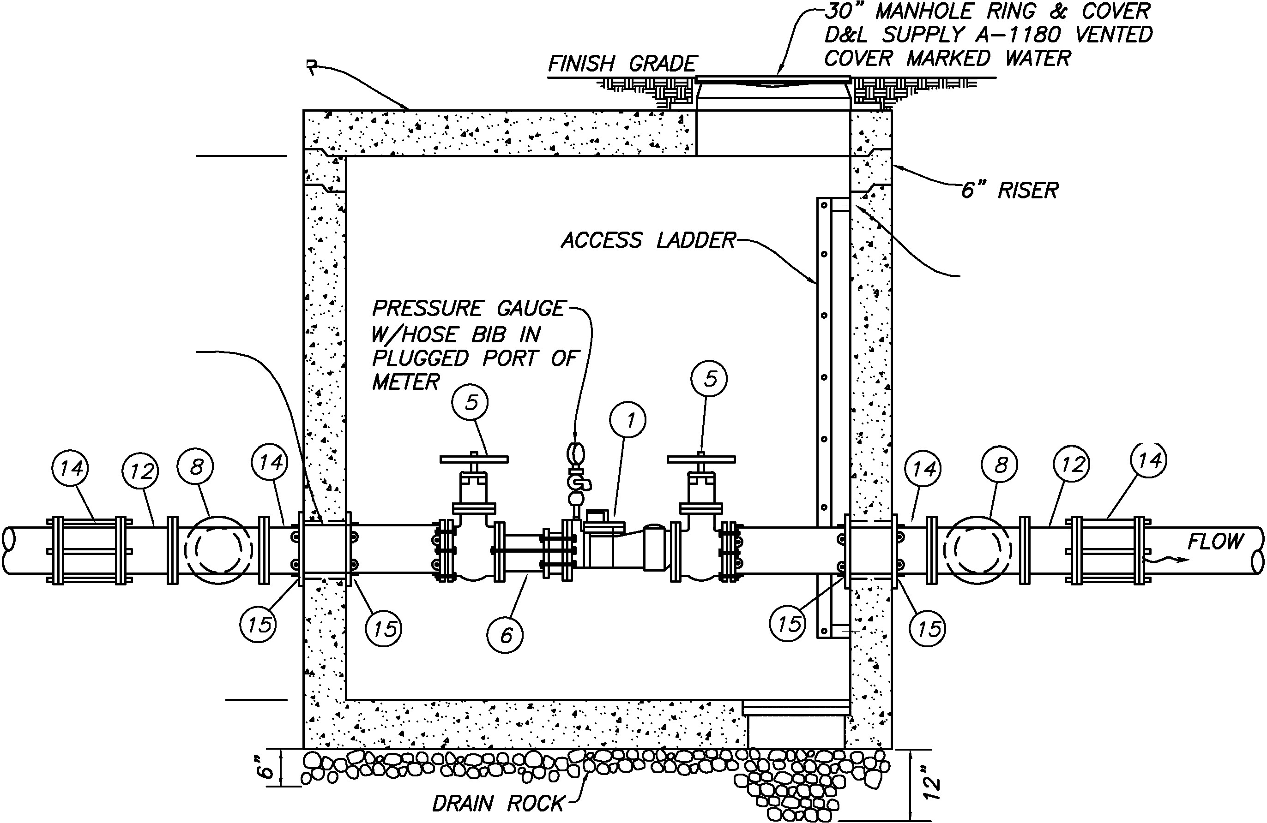N
(/)
0
u:'
<(
0
z
<(
f­
(/)
z

s
0
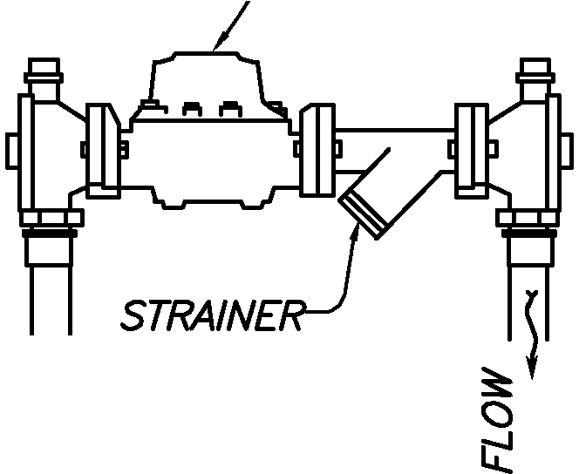
f-

<(
=i
f­
z

<(
2
/
(J)
u
\.._
0
u
C
0
+--'
(/)

C
s
0
f-

0
::J
+--'
C
0
2
/
(J)
u
0
u
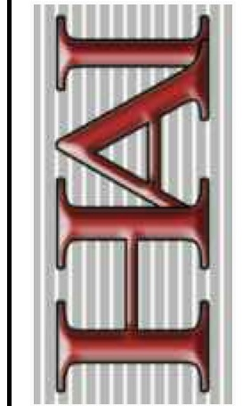
C
0
+--'
(/)
/

u z

3,000 PSI @ 28 DAYS CONCRETE BLOCKING

PLAN VIEW

4" THICK x 2'-0"
;/ ' DIAMETER CONCRETE VALVE
' \ BOX STABILIZING PAD IN
j,7. PAVED AND UNPAVED
AREAS
COMPACTED BACKFILLED EARTH

FLANGE FtmNG
55 TAPPING SLEEVE
WITH FULL GASKET. -FLANGE x MJ
SEE NOTE 1 RESILIENT WEDGE
VALVE
RESTRAINT FLANGE SYSTEM REQUIRED IN HIGH PRESSURE AREAS

CONCRETE BRICK BLOCKING
SEE NOTE 2

POUR 3000 PSI CONCRETE BLOCKING AND
FOOTING UNDER ASSEMBLY AS SHOWN SECTION A -A
NOTES:
- Concrete blocking is to be formed to ensure accesibility to fittings and poured against undisturbed earth.

- Fittings ore to be completely wrapped with plastic, prior to pouring concrete.

- Concrete ta be minimum 3,000 psi. @ 28 days.

4 " TO 12" STANDARD TAPPING SLEEVE AND
VALVE ASSEMBLY DETAIL
SCALE: NONE CONSTRUCnON R£0UIR£M£NTS:
WH£R£ APPUCABL£, ANO UNLESS OTHERWISE SP£CIF/£0, CONSTRUCnON OF PUBUC WORKS FACILJn£S AND INFRASTRUCTURE SHALL COMPLY WITH
TH£ LATEST £OmON OF TH£ AMERICAN PUBUC WORKS ASSOCIAnON MANUAL OF STANDARD SP£CIFICAnONS WHICH AR£ ADOPTED BY R£FER£NC£ AS A COMPANION DOCUMENT TO TH£S£ DRAWINGS. R£SOLUnON OF ANY INC0NSIST£NCl£S 8£TW££N TH£S£ DRAWINGS AND TH£ ADOPTED SP£CIFICAnONS WILL 8£ MAD£ BY TH£ TOWN £NGIN££R.
 | JIM FLINT, P.E. DATE  FOR HANSEN AND ASSOCIATES | APPROVED  HANSEN & ASSOCIATES, INC.  Consulting Engineers and Land Surveyors  538 North Moin Street. Brighom. Utah 84302  Visit us at www.haies.net  Brigham City Ogden Logan  (435} 723-3491 (801) 399-4905 {4J5) 752-8272  MANTUA TOWN MAYOR DATE | REVISION DATE:  9-30-14  1------------...  DATE: 1 1/23/ 13  I-----------<  SCALE: NONE | Town of Mantua  Public Works Construction Standards | SHEET:  13  OF 14 SHEETS
 |  |  |  | MISCELLANEOUS CULINARY WATER SYSTEM DETAILS

Li_
0
O_

0
f-

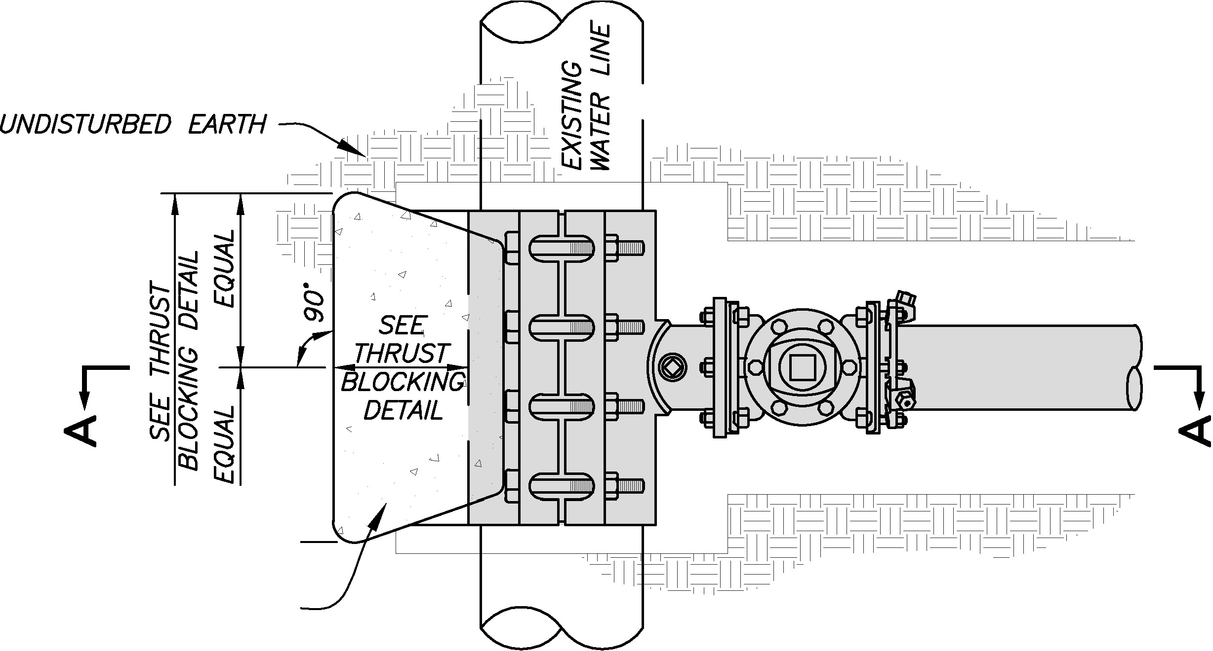(_')

s
0

2
<(

U)

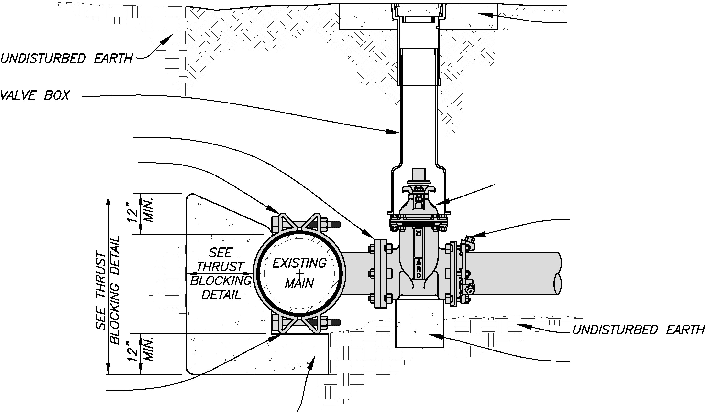I";
I
0

0
N
(/)
0
u:'
<(
0
z
<(
f­
(/)
z

s
0
f-

<(
=i
f­
z

<(
2
/
(J)
u
\.._
0
u
C
0
+--'
(/)

C
s
0
f-

0
::J
+--'
C
0
2
/
(J)
u
0
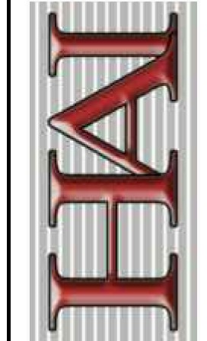
u
C
0
+--'
(/)

u z
/

Li_
0
O_

0
f-

(_')

s
0

2
<(

8" TO 12" FROM FACE OF CURB

30" WIDE CURB AND GUTTER

==o

MAILBOX PER USPS

I
NEWSPAPER BOX

4 "x4" WOOD OR OTHER STYLE
/ POST PER USPS WIDTH VARIES

SIDEWALK
3 ' 6" M!N. I • 3'-6 " MIN. ·1
CENTER TO CENTER OF POST

NEWSPAPER BOX

FINISH GROUND
GENERAL NOTES:

- USE ANY COMMERCIALLY AVAILABLE MAILBOX MEETING U.S. POSTAL SERVICE (USPS} REQUIREMENTS AND DETAILS ON THIS DRAWING.

- HEIGHTS TO MAILBOXES ARE SUPERCEDED BY USPS REQUIREMENTS IF THEY DIFFER FROM THOSE SHOWN HEREON.

- DO NOT EXTEND NEWSPAPER BOXES BEYOND THE FRONT OF THE MAILBOX WHEN THE MAILBOX DOOR IS CLOSED.

- FOR MAILBOX AND NEWSPAPER STOP TURNOUT WIDTHS 8 FEET OR GREATER, REFER TO MAIL STOP TURNOUT DETAILED HEREON.

- IN THIS STANDARD DRAWING, DIFFERENT RESTRICTIONS ARE IMPOSED ON THE PERMITTED LOCATION OF DECORATIVE MAILBOX SUPPORTS OR HOLDERS, CONSTRUCTED OF MASONRY OR OTHER RIGID MASSES, WHICH CAN SIGNIFICANTLY INCREASE THE HAZARD

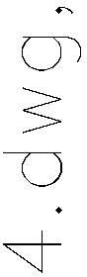

I";
I
0

0
N
TYPICAL FOR SINGLE OR GROUP MAILBOXES

DECORATIVE MASONRY OR OTHER DECORATIVE TYPE MAILBOX SUPPORTS ARE PERMITTED IN PARK STRIPS WHERE ROADWAY CURB AND GUTTER EXISTS, SO LONG AS THEY COMPLY WITH THE SETBACKS ABOVE AND CONFORM TO USPS REQUIREMENTS.

MAILBOX IN PARK STRIP
NOT TO SCALE

es
c::i
:5
o

FRONT VIEW
TYPICAL GROUP MAILBOX AND NEWSPAPER BOX
NOT TO SCALE

MASONRY OR OTHER DECORATIVE TYPE
STRUCTURE COMPLYING WITH USPS --------- -
POTENTIAL TO THE TRAVELING PUBLIC AND ROAD MAINTENANCE EQUIPMENT WHEN A LOW-YIELDING ROADSIDE OBSTRUCTION IS IMPACTED.

(/)
0
u:'
<(
0
z
MAILBOX PER USPS

==o
i;i
ole.
t3

<(
f­
(/)
z

s
0
f-

<(
=i
f­
z

<(
2
/
(J)
u
\.._
0
u

NEWSPAPER BOX 4"x4" WOOD POST REQ'

MIN. 4. 0' ALL WEATHER SHOULDER ASPHALT PAVEMENT
2% SLOPE---
--------i ---,---.,... E:l

ASPHALT PAVEMENT

MIN. 8. 0' ALL WEATHER SHOULDER TURNOUT FOR DECORATIVE STYLE MAILBOX SUPPORTS
/

ole.
i.J..J
(.'.)
G '-1-

EDGE OF TRAVELED WAY

MASONRY OR OTIICR \ DECORATIVE TYPE MAILBOX REFERENCED IN NOTE NO.
i
4 AND 5 ABOVE.

C
0
+--'
(/)

C
s
0
f-

0
::J
+--'
C
0

TYPICAL FOR SINGLE OR GROUP MAILBOXES
MAILBOX ON RURAL OR LOCAL ROAD WITH ALL WEATHER SHOULDER
NOT TO SCALE

ROADSIDE DRAINAGE SWALE---­
MIN 12" DIA. DRAINAGE CULVERT WHERE REQ 'D TO FILL IN SWALE TO PROVIDE MAILBOX TURNOUT
o
Cl:l
""I;
a C'\J '-1-
MAIL STOP TURNOUT LAYOUT
NOT TO SCALE

2
/
(J)
u
\.._
0
DECORATIVE MAILBOX ON RURAL OR LOCAL ROAD WITH ALL WEATHER SHOULDER
NOT TO SCALE

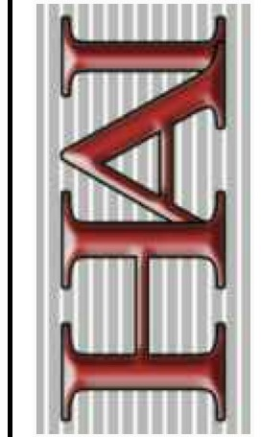
u
C
0
+--'
APPROVED
HANSEN & ASSOCIATES, INC.
REVISION DATE:

9-30-14

Town of Mantua

Public Works Construction Standards
•tso· ··ro
SHEET:

(/)
Consulting Engineers and Land Surveyors
538 North Moin Street, Brighom, Utoh 84302 >---- -------< ••A V A
s-r AR'"S
&1e1u n A nen 80' V 14

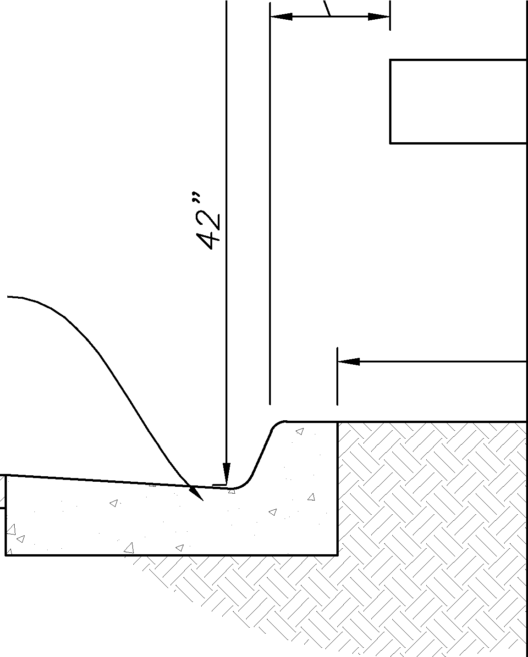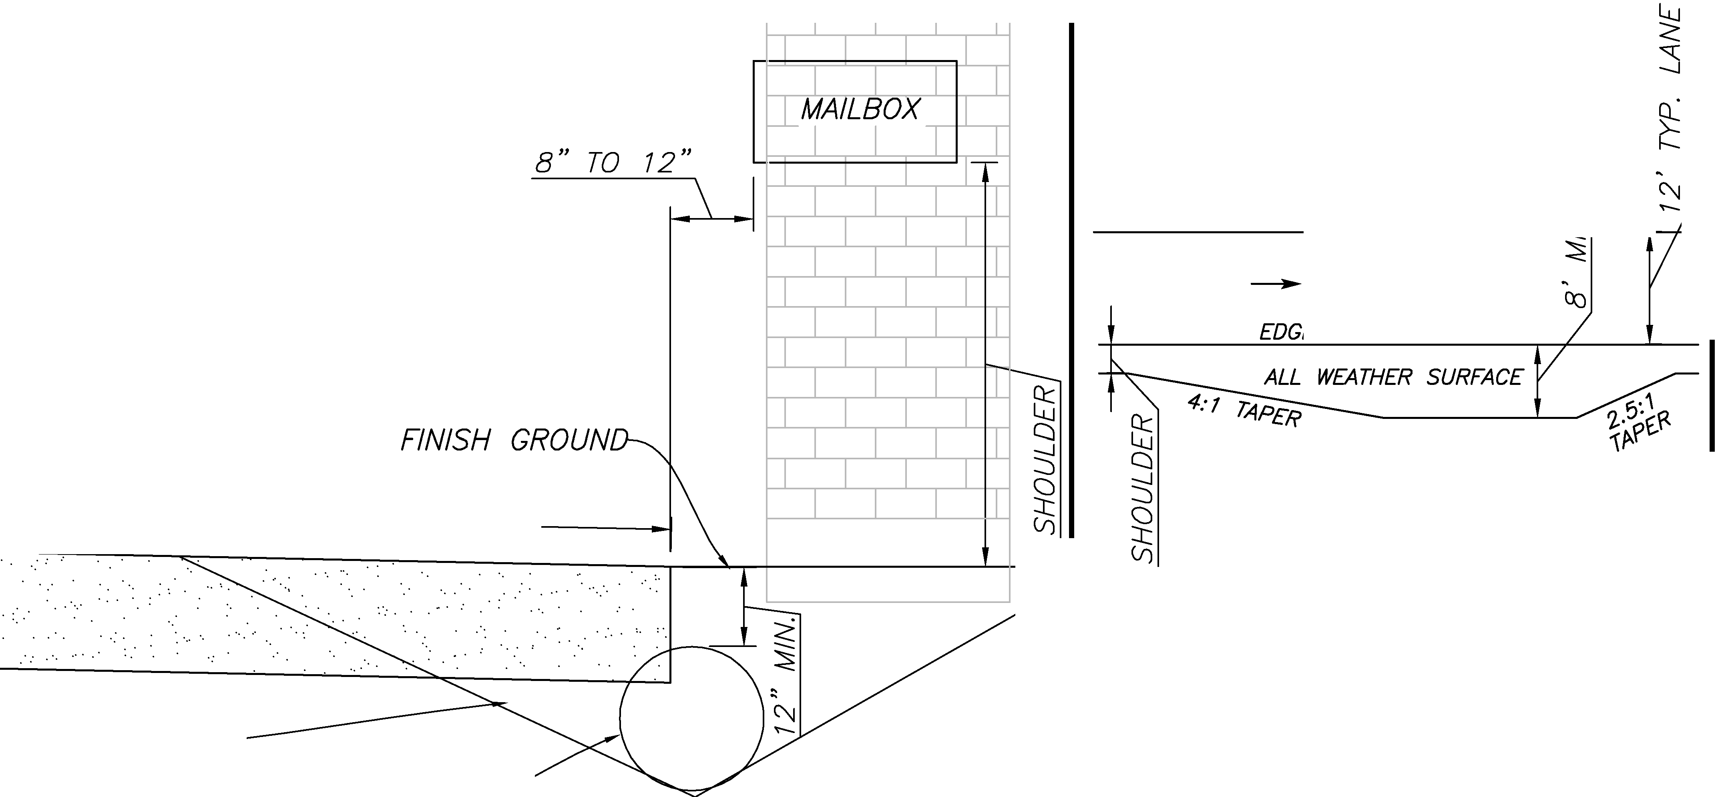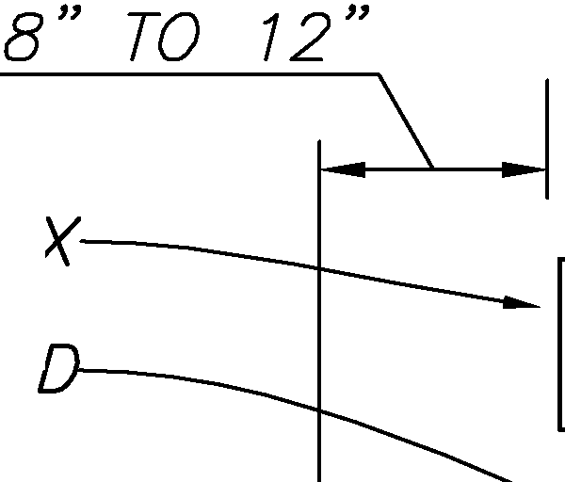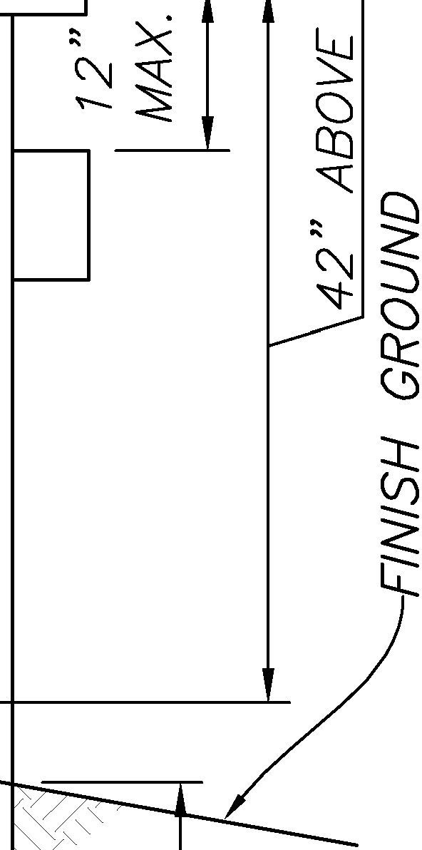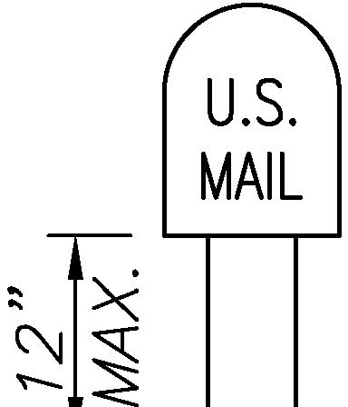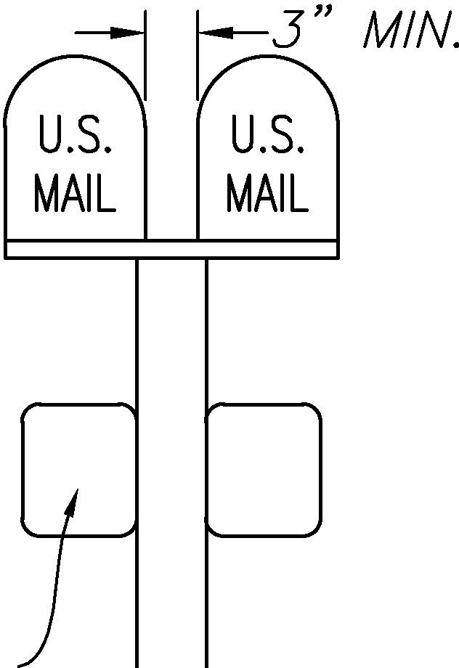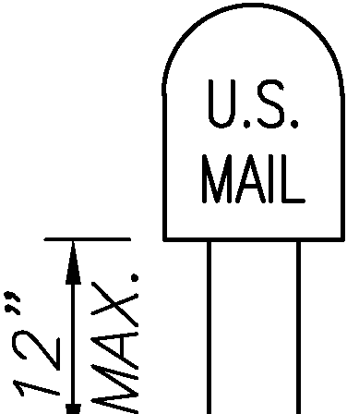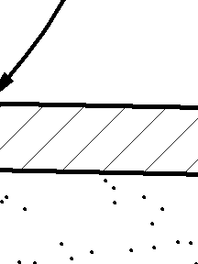
u JIM FLINT, P.E. DATE
/ FOR HANSEN AND ASSOCIATES
z

MANTUA TOWN MAYOR

DATE
Visit us at www.haies.net DATE· 5/ 19/ 2014 lffl11l :A IYl 1w,;;; n.;,r11r,;;;n :A
Brigham City Ogden Logan . A &lft
(4.15) 123-3491 rso1J 399-4905 (4.15) 752-8272 I 111'1Ul1 a.,,
SCALE: AS NOTED FOR COLLECTOR AND LOCAL COMMUNITY ROADS

OF 14 SHEETS

